Reading Guide
Text 10a: N. Sivin, ‘Why the Scientific Revolution Did Not Take Place in China – or Didn’t It?’
Text 10b: Shen Kua, Brush Talks from Dream Brook (夢溪筆談)

Core question:
What has the scientific revolution revolutionized?

Introduction:
→ The Needham Question
→ Nathan Sivin’s standpoint
→ Non-existence of unity in Chinese Science
→ Two fallacies of historical reasoning. Different dimensions of scientific revolution. Scientific revolution in China.
→ Shen Kua’s Brush Talks from Dream Brook

Why was China overtaken by the West in science and technology, despite its earlier successes? This question, also known as “Needham's Grand Question” or “The Needham Question”, has inspired many debates. One focus of the debates is on the two assumptions behind this question: the existence of Chinese science and the superiority of Chinese science over western science. Needham approached the Grand Question from a social-political point of view. He suggested the rise of bourgeoisie in the West, which never happened in China, was the primary cause of emergence of science. This view has been accepted for quite a long time especially by Chinese people. However, some cast doubt on this approach and also on the assumption behind the Needham Question.

The renowned sinologist Nathan Sivin is Emeritus Professor of Chinese Culture and of the History of Science at University of Pennsylvania. In this oft-cited paper, he presents a comprehensive treatise on the Question. The most famous quote from it might be “It is striking that this question—Why didn’t the Chinese beat Europeans to the Scientific Revolution?—happens to be one of the few questions that people often ask publicly about why something didn’t happen in history. It is analogous to the question of why your name did not appear on page 3 of today’s newspaper.” In other words, Needham’s question is out of question.

Regarding the first assumption, Sivin argues that there were sciences indeed but no unity in Chinese science. Chinese did not combine insights to form a general understanding. Such unity is not found even in Shen Kua’s system of thought. He also argues that the superiority of Chinese science is out of question because “comparison between strong traditions of science and technology is meaningful only when it is based on the ideas and social arrangements of different civilizations.”

After he has pointed out the two fallacies of historical reasoning, one being confusing an earlier state of culture as a necessary condition and the other the absence of the subsequent state as an inhibiting factor, he draws our attention to different dimensions of scientific revolution. Lastly, he suggests there was scientific revolution in China which was a revival of traditional Chinese astronomy. However, this revival did not bring the expected social consequences.

Shen Kua’s Brush Talks from Dream Brook is a collection of records covering numerous areas including military, magic, law, academic matters, mathematics, astronomy, meteorology, physics, hydraulic engineering, biology, agriculture and medicine. From the five passages chosen from this book, one can have a glimpse at the depth of scientific content and also the unity, if any, of Chinese science.

Suggested outline of the text:
Text 10a
I. Introduction
1: The two conclusions of this essay.
2: The study of China is a flourishing field in the history of science.
3. Needham’s first and second questions.
II. The absence of unity in Chinese science
4-7: Attempt to refute the assumptions behind the second question (i. application of Chinese science in daily life, ii. superiority of Chinese science over western science)
4-5: Answer to “application”: The natural knowledge being applied to human needs was not Chinese science (but technology). Science (only elites knew) and technology (belonged to artisans) were two different things.
6-7: Answer to “superiority”: It is out of question. Comparison between civilizations involves many aspects. “Historians have more urgent things to do than to prove that every other culture was inferior to the one they specialize in.”
8-17: The non-existence of unity in Chinese science, with Shen Kua’s system of thought as a case.
8: Shen Kua and his academic achievements.
9-12: Chinese did not combine insights to form a general understanding (9-10), which is not found even in Shen Kua’s system of thought (11-12).
13-14: The political situation in Shen’s time that allowed diversity in interest.
15-16: The lack of linkage between different fields of knowledge in China.
17: Conclusion: The absence of unity of Chinese science.
III. The nature of the Scientific Revolution Problem
18: Introduction: “Why something did not happen?” has no direct answer.
19-20: People keep asking the question because of its heuristic nature that lies in a special urgency.
21: The urgency lies in that the question relies on shaky assumptions: the Scientific Revolution is what i. we assume people ought to have and ii. we do not know whether people wanted to have.
22: One more assumption behind the problem: the Western model of the Scientific Revolution is a standard pattern for all capable civilizations and will lead to similar institutional and social changes.
23-25: The two convictions behind the assumptions:
23: i. The European civilization is closer to the reality than other civilizations are. However, historical study does not support this.
24-25: ii. Modern science is transcendental, universal, objective and value-free. However, this universality of modern science is doubtful.
IV. Modern science is not value-free in other dimensions (elaboration on Conviction ii)
26-27: Dichotomies in science as an example.
26: Demarcation between science and religion, mind and body, etc and the absence of such demarcation in Chinese science.
27: The existence of the distinction as a proof of parochialism in the foundation of science.
28-29: Definition of universality.
28: Modern science and technology are not universal in the sense that they have not transcended European patterns of thought but have only repelled old thoughts.
29: True universality requires modern technology to coexist with and serve cultural diversity.
30-34: Main theme – Modern science is not independent of its social and historical origin:
30: Introducing the conclusion: A universal and value-free modern science does not exist.
31: Modern science itself is rigorous, internally consistent and exact. But a law or a theory will lose these characteristics when translated for non-scientists.
32: Then values will creep in when people deal with the relation between science and other subjects, society, political situations, etc.
33: Conclusion: Modern science is not international nor universal in the cognitive, practical, normative and social dimensions.
34: Remark: On the other hand, modern science is not completely European because impacts from other cultures cannot be ignored.
V. Fallacies of Historical Reasoning
35: Introduction – there are fallacies of historical reasoning.
36-38: First fallacy – an earlier state of culture is confused as a necessary condition.
36-37: The argument that faults the Chinese for not developing a scientific method. Other examples of the argument.
38: The fallacy is that a given circumstance is assumed to be a necessary condition.
39-43: Second fallacy – the absence of the subsequent state is confused with an inhibiting factor.
39-41: The Book of Changes as an example.
42-43: Difficulties of the reasoning.
44: A summary of the two fallacies.
45-51: Consequences of these fallacies and other remarks.
45: The previous assumptions (Para.21, 22) are the root of these fallacies.
46-48: How these fallacies lead to disastrous assumptions.
49-50: The acceptance of these assumptions leads to the uncritical acceptance of the “static character” hypothesis and “Oriental despotism” hypothesis for eastern countries.
51: One more fallacy: some people look at intellectual factors alone, while some at socio-economic factors alone.
VI. Dimensions of the Scientific Revolution
52: Introduction.
53-55: Intellectual dimension: the Scientific Revolution defined “is it true?” as the ultimate question and gave up the old ones. The truth is public, verifiable, morally neutral, etc. No such change happened in China.
56-57: Social dimension: the Scientific Revolution redefined what is socially desirable and what is not.
58: Conclusion
VII. Scientific Revolution in China
59: Introduction.
60-61: The introduction of western mathematics and astronomy a little after 1600 did not give rise to a revolution like that happened in Europe.
62: But there was a revival of traditional Chinese astronomy.
63-66: Why this revival did not have the expected social consequences.
67: A counter example.
68: Scientific Revolution of the western type happened only in the late 19th century.
VIII. Conclusion
69: Difficulties in the present study.
70: The Revolution in Europe and that in China have many dimensions.
71-72: Many things have yet to be studied in Chinese science before there is a breakthrough.
Text 10b: skipped
Useful Diagrams:
1. The chessboard mentioned in ‘Total Number of Possible Situations in Chess’ (304) looks like this:
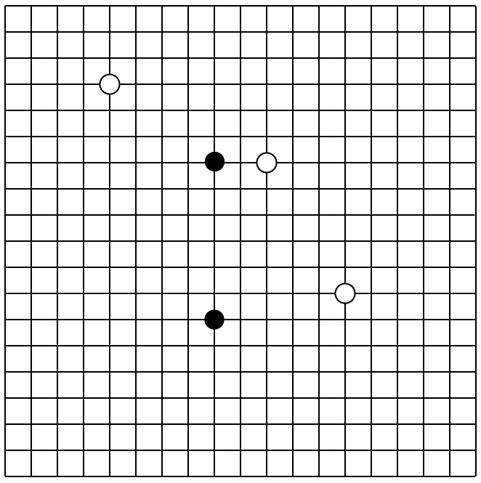
On the chessboard of Wei Chii (now usually referred to as “Go”), there are 19×19 positions to place the white and black pieces.
2. In ‘The Compass’ (437), Shen Kua said a compass “always inclines slightly to the east, and does not point directly at the south”. Now we know it is due to the fact that the magnetic north does not align with the geometrical north. The angle between the two north’s (δ in the figure below) is called “magnetic declination” (磁偏角) in modern terminology.
For most part of the East China, the magnetic north tilts a bit towards west from the geometrical north (the direction towards Polaris). The magnetic south therefore inclines to the east. In Hong Kong, δ is around -2.5º (the negative sign indicates a westward declination).
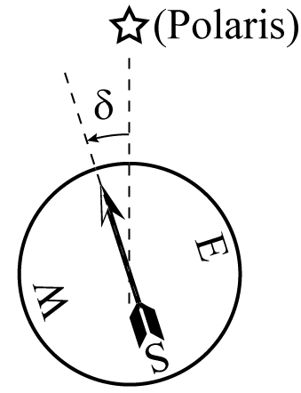
This website will find your IP address and tells you the magnetic declination at your position: http://magnetic-declination.com/.

Study Questions
(Answers can be found at the end of this session.)

(Text 10a, Para. 1-3: Introduction)

1. Which of the following statements are the conclusions of the text?
I. | Historians are not able to answer the question of “why the Scientific Revolution did not take place in China”.
II. | A Scientific Revolution did happen in China.
III. | European influence on India is less significant than that upon China.
IV. | Only Chinese are interested in the study of China.

(a) I and II only. (b) III and IV only. (c) I, II and III only.
(d) II, III and IV only.

2. What is Needham’s Scientific Revolution problem about?
(a) | Why did European civilization rejuvenate between the 1st and 14th century?
(b) | Why was the natural knowledge that applied to human needs in the West more successful than in ancient China?
(c) | Why were meteorites observed between the 1st and 14th century in the West only?
(d) | Why modern science had not developed in Chinese civilization?

(Text 10a, Para. 4-7: Refute Needham’s assumptions)

3. What does the author think about the application of natural knowledge to human needs in ancient China?
(a) | Literacy has already spread over different regions in China.
(b) | The application of natural knowledge is technology rather than science.
(c) | Most artisans transmitted their skills to their children only.
(d) | Various kinds of applications are closely connected.

4. What does the author think about the superiority of ancient Chinese over Europeans?
(a) | There is no obvious conclusion to this question.
(b) | Mathematical astronomy in ancient China reached a high level of accuracy.
(c) | It is urgent for historians to study which civilization is superior.
(d) | The author agrees that ancient Chinese were superior to Europeans.

(Text 10a, Para. 8-17: Non-existence of unity in Chinese science)
5. What does the author illustrate with the example of Shen Kua’s academic achievements?
(a) | Ancient Chinese were superior to Europeans.
(b) | Ancient Chinese did not integrate insights into general understanding.
(c) | Establishment of schools and universities in Europe was not worth the effort.
(d) | Modern science failed to understand what Shen Kua did.

6. What does the author illustrate with the examples of the job nature of astronomers, doctors, and alchemists in China?
(a) | China was superior to Europe in these fields of knowledge.
(b) | Shen Kua possessed knowledge of astronomy, medicine, and alchemy.
(c) | There was apparently no linkage between different fields of knowledge in China.
(d) | Chinese philosophers had no influence on the development of these fields of knowledge.

(Text 10a, Para. 18-25: The nature of the Scientific Revolution Problem)

7. Which of the following statements are some “shaky” assumptions behind the Scientific Revolution problem?
- Scientific revolution is what every culture ought to have.
- Nobody wants to have Scientific Revolution.
- Civilizations which have the potential for a Scientific Revolution should follow the western path.
(a) I and II only. (b) I and III only. (c) II and III only. (d) I, II and III.

True or False:
8. Most scientists have the conviction that science is universal, objective, and value-free.

(Text 10a, Para. 26-34: The nature of modern science)

True or False:
9. The author thinks that modern science has achieved true universality.

10. According to Sivin, there are differences between the modern scientific activities in China and that in the United States. What are they?
- The relation of basic and applied science to general culture.
- The role of scientists in defining research programmes.
- The connection of political ideas and scientific knowledge.
(a) I and II only. (b) I and III only. (c) II and III only. (d) I, II and III.

 | First statement | Second statement
(a) | True | True | The 2nd statement is a correct explanation of the 1st statement.
(b) | True | True | The 2nd statement is NOT a correct explanation of the 1st statement.
(c) | True | False
(d) | False | True

(Text 10a, Para. 36-38: First fallacy)  11. Bacon’s scientific methodology is important to the development of modern science. | Bacon’s scientific methodology was developed in the West.
(Text 10a, Para. 36-38: First fallacy)  12. Ancient Chinese failed to develop a unified scientific system. | Chinese astronomers were not interested in applied technical sciences.
(Text 10a, Para. 39-43: Second fallacy)  13. China failed to beat Europe to the Scientific Revolution. | Chinese scholars oriented themselves towards human institutions rather than nature.

(Text 10a, Para. 39-43: Second fallacy)

14. Why does the author disagree that the Book of Changes is an inhibiting factor in the development of scientific ideas in China?
I. | It is wrong to consider the Book of Changes as a static classificatory system.
II. | A proof is needed to explain that China would go further without the Book of Changes.
III. | A significant Scientific Revolution did happen in China.

(a) I only. (b) III only. (c) I and II only. (d) II and III only.

(Text 10a, Para. 45-51: Consequences of fallacies)

15. What does the author illustrate with the example of the invention of automobile in Europe?
I. | The horse and buggy is a necessary condition for the invention of automobile in Europe
II. | The horse and buggy is an inhibiting factor for the invention of automobile in China.
III. | Joint use of the fallacies of historical reasoning proves that Europe’s breakthrough was inevitable.

(a) I only. (b) II only. (c) III only. (d) II and III only.

True or False
16. Intellectual factors alone are sufficient to explain that China failed to beat Europe to modern science.

17. According to the author, socioeconomic factors alone are sufficient to explain that China failed to beat Europe to modern science.

(Text 10a, Para. 52-58: Dimensions of the Scientific Revolution)
18. What question(s) do the scientists in modern times naturally ask?
- Is it beautiful?
- Is it true?
- Is it morally improving?
(a) I only. (b) II only. (c) I and II only. (d) II and III only.
19. What questions did the scientists before the Scientific Revolution ask?
- Is it beautiful?
- Is it true?
- Is it morally improving?
(a) I and II only. (b) I and III only. (c) II and III only. (d) I, II and III.
True or False:
20. According to Sivin, the Scientific Revolution only transformed the scientific knowledge itself, but not the relationship between scientific thoughts and society.
(Text 10a, Para. 59-68: Scientific Revolution in China)

(a) | True | True | The 2nd statement is a correct explanation of the 1st statement.
(b) | True | True | The 2nd statement is NOT a correct explanation of the 1st statement.
(c) | True | False
(d) | False | True

21. There was no tremendous social change in the Scientific Revolution in China. | The Scientific Revolution did not result in a fundamental reorientation of thought about nature.
True or False:
22. In the late Ming Dynasty, the operational control of the Astronomical Bureau was handed over to Jesuit missionaries.
(Text 10a, Para. 69-72: Conclusion)
23. Sivin thinks that the Scientific Revolution problem raised by Joseph Needham is an everlasting question.
(Text 10b: Brush Talks from Dream Brook)
24. Shen Kua gives a thorough explanation of the property of compass.
25. Shen Kua improves the printing techniques of ‘Moveable Type Printing’ .

End —

In Paragraph 8, Sivin mentions that Shen Kua discussed magnetic declination, printing with movable type and application of permutations in traditional Chinese mathematics, and explained the process of land formation by both deposition of silt and erosion. All the original documemts can be found in Text 10b. The reader is referred to ‘The Compass’ (437), ‘Moveable Type Printing’ (307), ‘Total Number of Possible Situations in Chess’ (304) and ‘Transformation of the Land and the Sea’ (430), respectively.
In Paragraph 11, Sivin mentions Shen Kua’s account of an experiment on the formation of rainbows. See ‘The Rainbow (357)’ in Text 10b.

